  

Get Started with Pico-8

Pico-8 is an application that comes installed on PocketC.H.I.P.. It offers a unique opportunity. You can play, change and create video games. Its screen resolution is only 128x128 with 16 colors. As mentioned on the [Pico-8 website](https://www.lexaloffle.com/pico-8.php), “the harsh limitations of Pico-8 are chosen to be fun to work with, encourage small but expressive (and manageable) designs...”

Pico-8 comes with everything you need. It includes games to play including ones made by community members and editors where you can modify existing games or create your own from scratch.

Pico-8 on PocketC.H.I.P. has proven to be an excellent way for students to be introduced to programming concepts and structure as well as game design.

PocketC.H.I.P. Pico-8 Tour

‘Splore Menu

‘Splore Menu Options

Pico-8 Console

PICO-8’s commands:

Play Games

Select Game

Game Controls

Exit Game

Edit/Create Games

Pico-8 allows you to modify existing carts, or create games of your own using the included code, graphics, and sound editors.

Edit Existing Game

Editor Options

Code Editor

Sprite Editor

Draw Tool

Stamp Tool

Select Tool

Pan Tool

Fill Tool

Map Editor

Sound Effects Editor

Music Editor

Create a Game From Scratch

Create & Save New Project

Create Sprite

Write Code

Exit Pico-8

From the ‘splore menu

From the Console

Pico-8 Resources

# PocketC.H.I.P. Pico-8 Tour

When Pico-8 is first launched the Next Thing Co. PocketC.H.I.P. Pico-8 guided tour automatically starts.

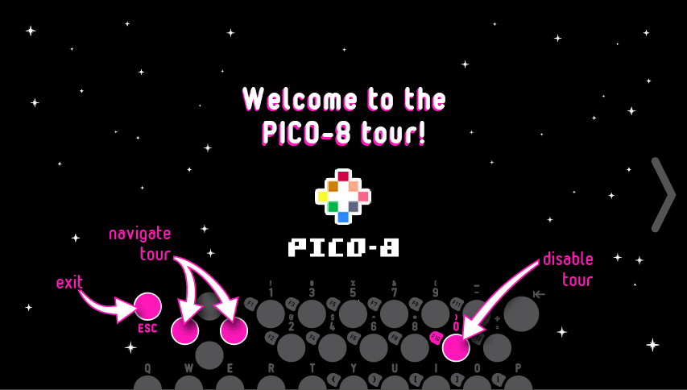

* To disable the tour and go straight to Pico-8 press “0”.
* Continue the tour by pressing the right arrow on the touch screen. The tour shows the basics of navigation and opening and editing a game.

C.H.I.P. Edition Title Screen

* When the tour ends, you will see the **Pico-8 C.H.I.P. Edition title screen**. Press “**0**” to exit and continue on to Pico-8.

# ‘Splore Menu

While Pico-8 starts up, a rainbow splash screen and the Pico-8 console will briefly appear along with the words “Booting Splore...”.

Afterwards, Pico-8 starts up in the ‘splore (short for explore) mode menu. Pico-8 has a strong community built around it that creates and shares games, assets and code. Dropping you into the ‘splore menu encourages you to play games and explore what the community has been working on. To see all the community made games, PocketC.H.I.P. needs to be connected to a WiFi network in order to download them.

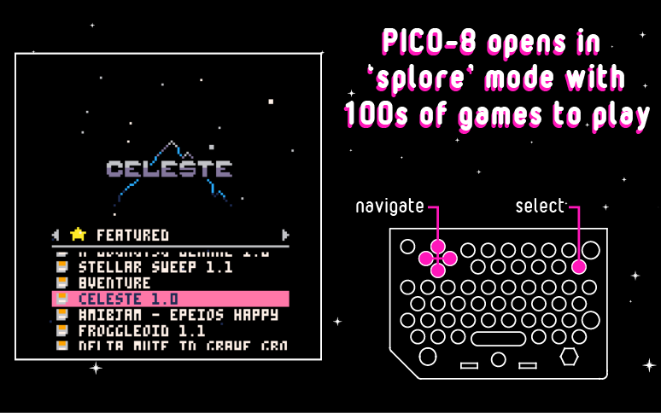

From the ‘splore menu games are selected and loaded.

How to navigate the menus:

* **D-pad Left and Right** -navigate and select the ‘splore menu options
* **D-pad Up and Down** - navigate the selected ‘splore menu option
* **Press “=” twice** - play a selected game
  + Some games may ask you to press other keys to start. They will be listed on the game’s start page.

## ‘Splore Menu Options

**Favourites** - Save games to the favourites list by pressing **ESC** while in a game and selecting “Favourite”. Games on this list are playable even when you're not connected to WiFi.

**New** - The newest additions to the PICO-8 community.

**Featured** - The top-rated games from the PICO-8 community.

**Work In Progress** - Recent releases of unfinished games submitted by members of the community.

**Collaboration** - User-submitted resources, remixes, and other useful things for others to use in their creations.

**Jam** - Collaboratively made games.

**Search** - Perform a text search of PICO-8's game library

**/** -Pico-8’s top directory. From here navigate to the Pico-8 folders on PocketC.H.I.P.

# Pico-8 Console

By default, Pico-8 enters into the ‘splore menu, however, the real control center is Pico-8’s console. The console is Pico-8’s own command-line interface, like PocketC.H.I.P.’s Terminal application. In the console you can load games, save games you are editing, reboot Pico-8 and more.

* To get to the console from the ‘splore menu, press **ESC** and select “**EXIT TO CONSOLE**”.
* To see all the available commands type “**help**” and press **return**.

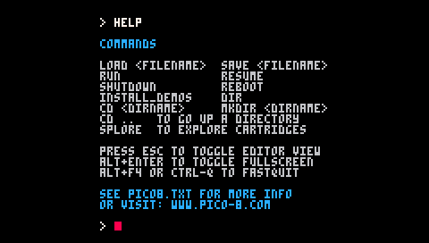

## PICO-8’s commands:

* **help** - lists the available commands
* **splore** - return to cart explorer
* **dir** - list the contents of the current directory
* **cd [directory name]** - change to the desired directory
* **cd** .. - go up a directory
* **cd /** - change back to top directory (on PICO-8’s virtual drive)
* **keyconfig** - customize the keys used by all games
* **mkdir** - make a new directory
* **folder** - open the current directory in the host operating system’s file browser
* l**oad [name of game]** - load a game from the current directory (this is like putting a cartridge into the console)
* **run** - plays the cart that is currently loaded
* **save [filename]** - saves the currently loaded cart with the given name (this is used when you’ve made changes to the game’s code, graphics, or music)

# Play Games

## Select Game

The easiest way to select and load a game is from the ‘splore menu. To start, it’s best to choose a game under Favourites, New or Featured. If you would like to explore collaboratively made games Jam and Collaboration are where you want to look.

Pico-8 comes with games already saved to the Favourites list. This is a good place to start. At NTC, our favorite is Celeste. You can see all finished cartridges (games) listed on [Pico-8’s website](https://www.lexaloffle.com/bbs/?cat=7&sub=2&mode=carts).

* To select Celeste from the Favourites list, press down on the D-pad until it’s highlighted.
* Press “=” twice to play the selected game.

## Game Controls

Not all games use the same controls. There are however, some similarities you can find listed below. Most games will tell you which keys to press once you start playing.

**Up, down, left, right** - D-Pad

**Jump** - D-Pad up, “0” zero

**Run** - “=” equal sign

**Action** - “-” dash

## Exit Game

Press **ESC** to exit a game and go back to the ‘splore menu at any point . This brings up a menu where you can choose to exit, favorite or edit the cart. Once in the ‘splore menu press **ESC** again to shut down Pico-8, or to go to the console.

# Edit/Create Games

# Pico-8 allows you to modify existing carts, or create games of your own using the included code, graphics, and sound editors.

There are two ways to get to the editors depending on what you want to do:

* Edit existing game
* Create game from scratch

## Edit Existing Game

For this example we will use one of our favorite games, Celeste.

* From the **‘splore menu** select Celeste and **press “=” twice** to start playing.

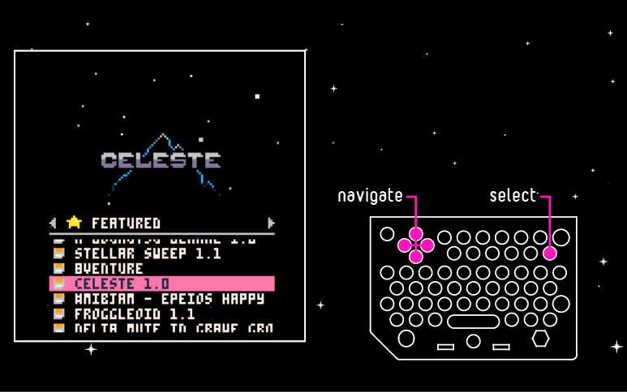

* Press **esc** and choose “**EDIT THIS CART**” and press **return**.

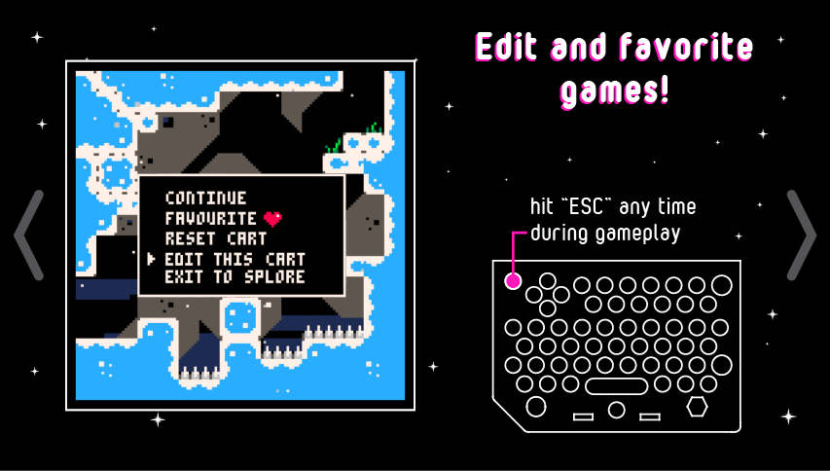

* You will be dropped into the code editor and will see all of Celeste’s source code.

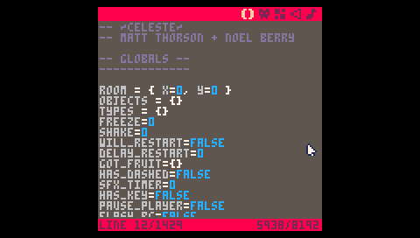

* From here, you can choose to edit the existing sprites, background, music and sound effects.

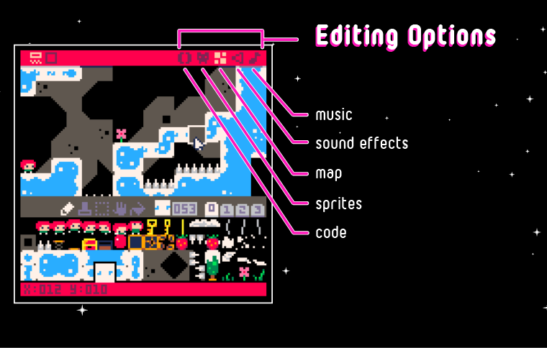

## Editor Options

Each editor can be accessed by tapping its associated icon in the upper right toolbar. From left to right this is which editor each icon is for:

* Code
* Sprite
* Map
* Sound Effects
* Music

### Code Editor

Pico-8 programs are written in the [Lua](http://www.lua.org/home.html) language. Edit a game’s source code or write a game from a blank page. Learn more about Lua from the primer available in the [Pico-8 online manual](https://www.lexaloffle.com/pico-8.php?page=manual).

Keyboard shortcuts while using the code editor:

* Hold SHIFT - select multiple characters or lines (or tap-and-drag)
* CTRL-X, CTRL-C, CTRL-V - cut, copy, or paste a selection
* CTRL-Z, CTRL-Y - undo, redo
* CTRL-F, CTRL-G - search for text, repeat search
* ALT-UP, ALT-DOWN - navigate to the previous, next function
* CTRL-D - duplicate current line
* TAB - indent a selection

### Sprite Editor

The sprite editor is designed to be used both for editing existing sprites while playing a game and for freeform pixel-level editing.

Use the sprite editor to create custom artwork to makes up map tiles, characters, or other graphical elements of the game. Below the **sprite editor window** there is an **8x8 pixel navigation box** that is displayed in the **sprite sheet window.** Navigate this box around the sprite sheet to choose what to display in the sprite editor window. It is possible to use the tools (pan, select) to edit larger areas.

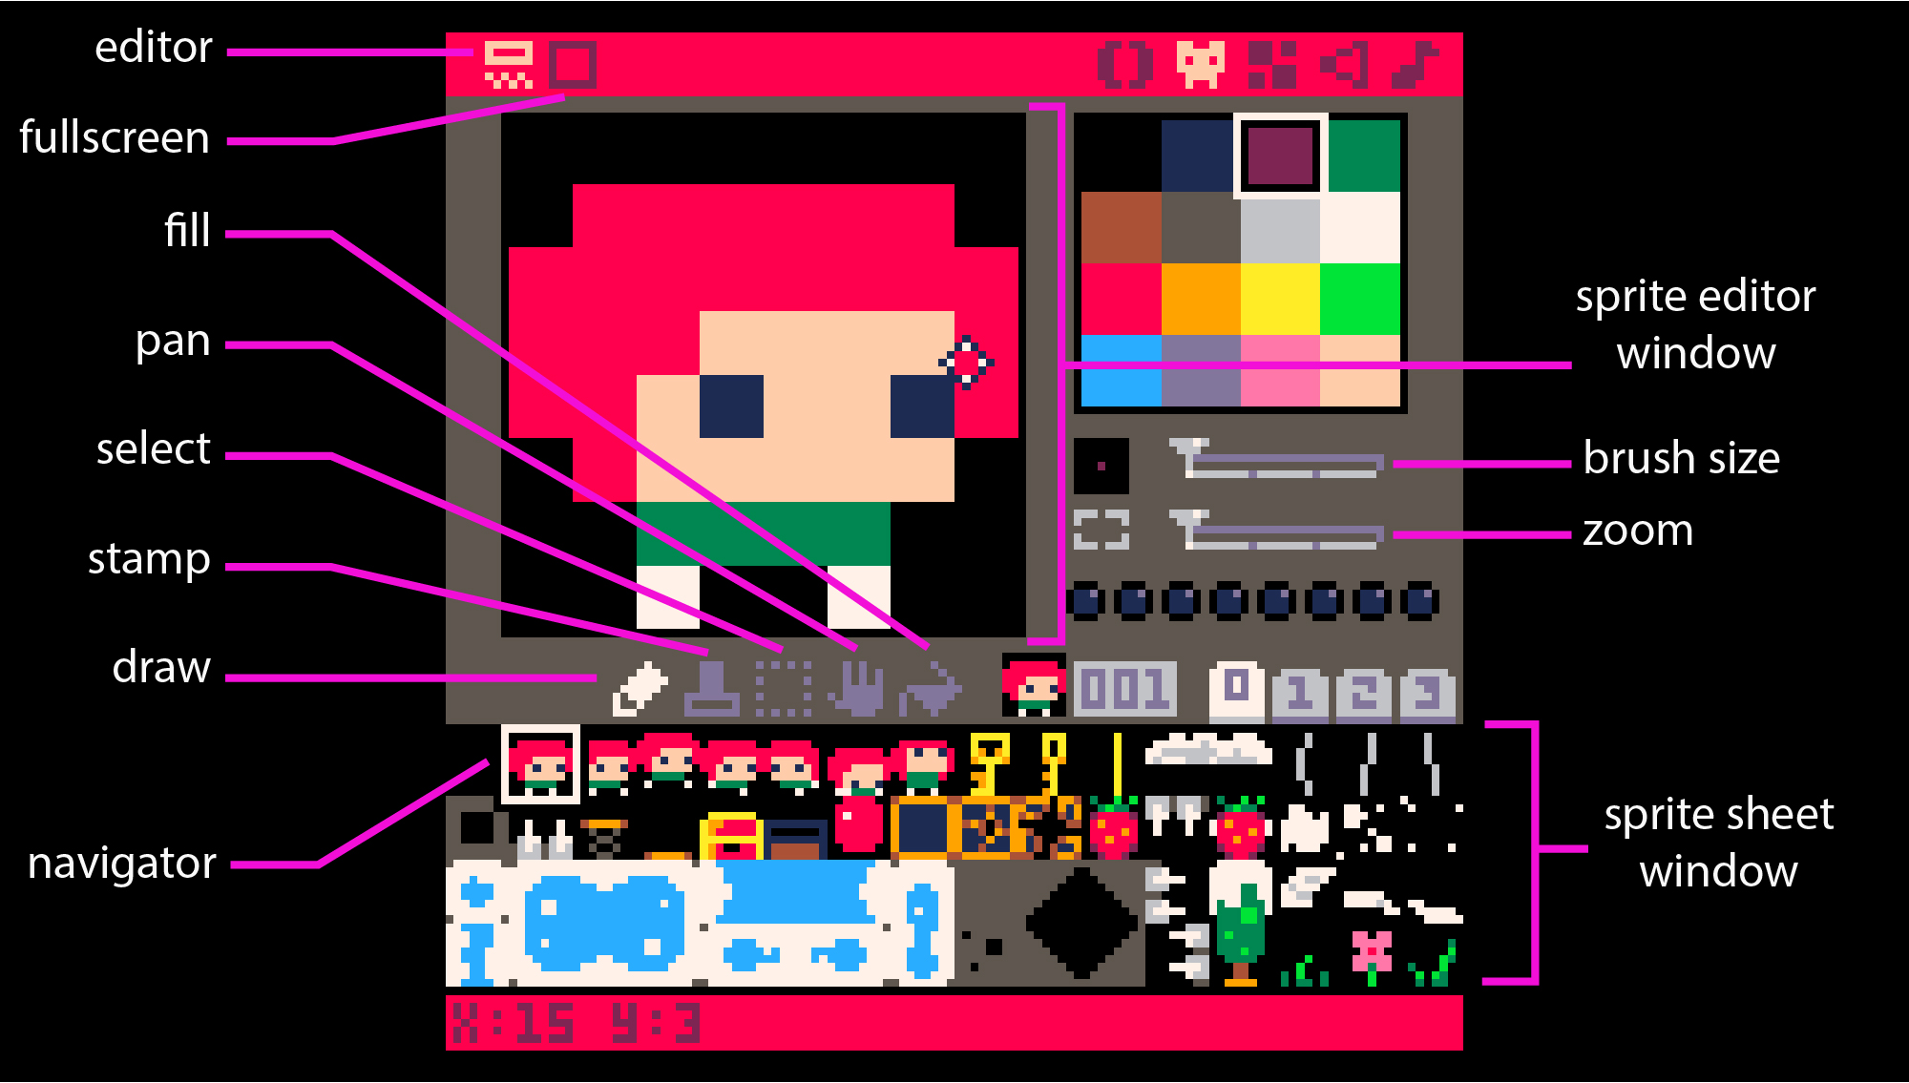

All the editor tools can be found directly below the 8x8 editor widow and above the sprite sheet. Use the following tools to create and edit sprites:

#### Draw Tool

* Click on the desired color from the color palate and then click in the editor window to apply the color to each pixel.
* Hold the **CTRL** button and click on a pixel to replace all of the same-colored pixels in the window with the selected color.

#### 

#### Stamp Tool

* Select an area of the sprite sheet that you want to copy using the select tool. Copy to clipboard with **CTRL+C**.
* Select the stamp tool and click the location in the editor window where you want the copied pixels to be pasted. Click the top-left corner of the editor window to place the design in the center.
* Hold **CTRL** while stamping to treat the copied black pixels as transparent.

#### Select Tool

* Shortcut: **SHIFT** or **S** + **tap** or **drag** to select.
* **Click and drag** with the select tool to highlight an area of the sprite sheet.
* Press **return** or **click** to select none.

#### Pan Tool

* Shortcut: **Spacebar** + **drag**
* **Click and drag** to move around the sprite sheet outside of the 8 x 8 view.

#### Fill Tool

* Fill an area with the selected color.
* If you have selected an area of the sprite sheet, fill will be limited to the color blocks of the design.
* If no selection is active, the fill will be limited to the area in the editor window.

### Map Editor

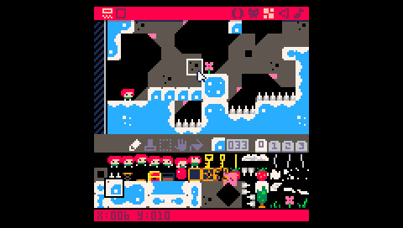

The tools for the map editor work similarly to those in the **sprite editor**. However, rather than choosing colors, select a **previously created sprite** from the sprite sheet

and use the **Draw** and **Fill** tool to place. In the above image you can see I have selected a piece of ground. Using the Draw tool I think drew four instances of this design to the right of my character to create bridge.

### Sound Effects Editor

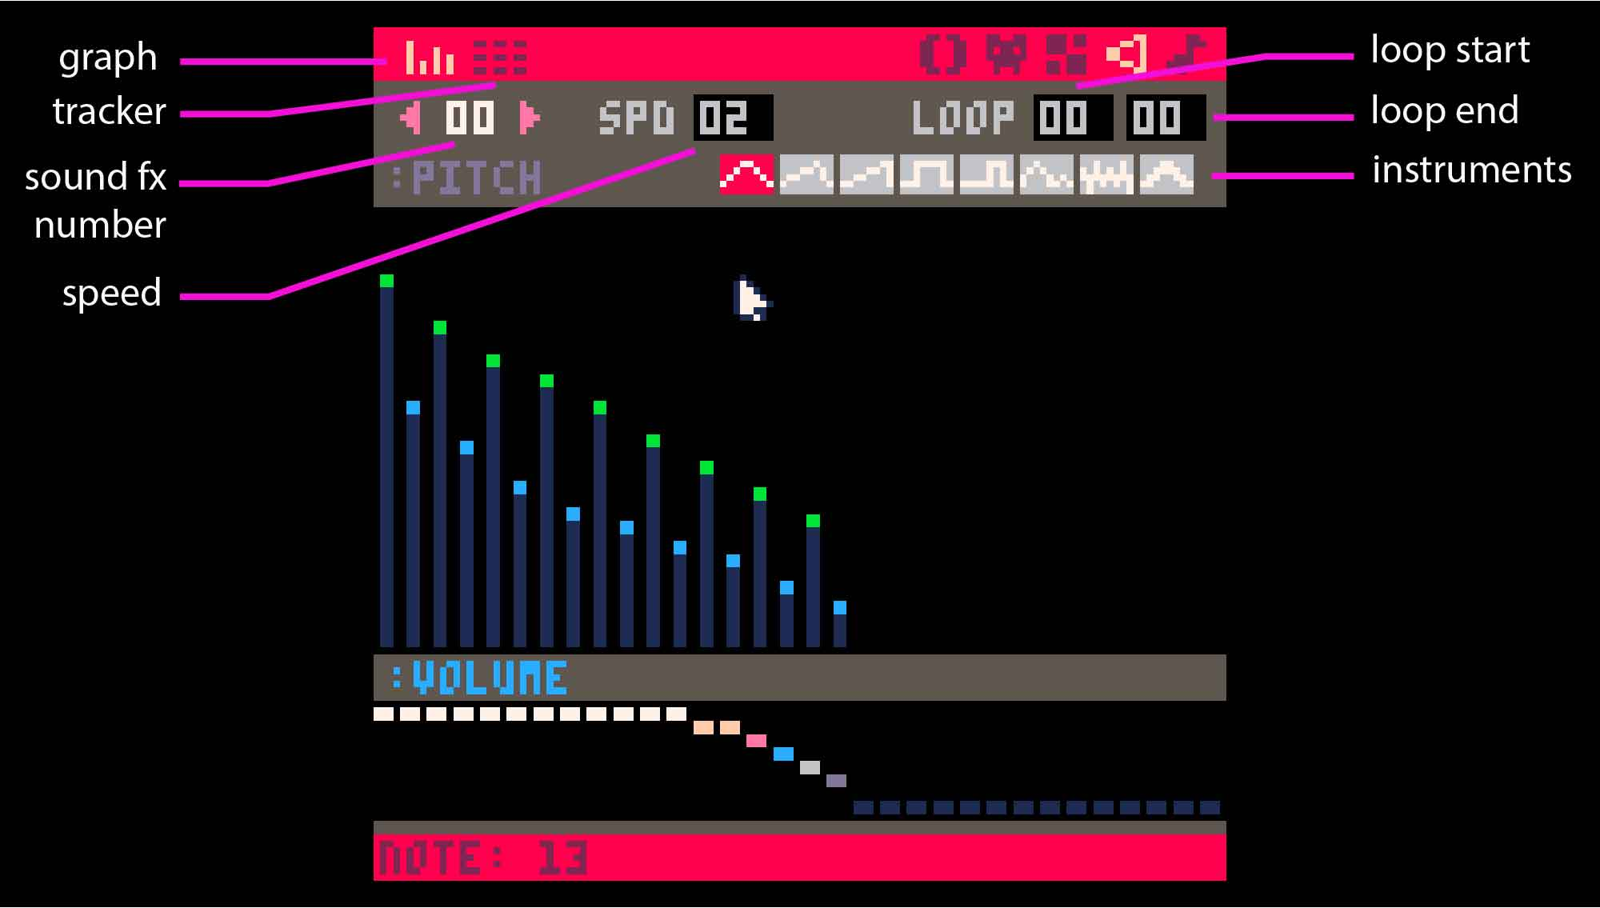

* Pico-8’s sound editor has two view modes: **graph view** and **tracker view**.
* In both views, the number in the top left, under the view selector is the **sound effect number**. Pico-8 can handle **64 different effects**.
* **Change the speed of the sound** by clicking on the number in the box labelled **SPD**. **Tap and drag** to change the value (dragging left decreases, dragging right increases). The **SPD value describes the duration of each note**, so the higher the value, the slower the sound will play.
* The **LOOP values** define the start and end points of a repeating section of the chosen sound effect. These can be changed by tapping and dragging like the SPD values.
* Select from the **eight available instruments** by clicking on the **gray waveform boxes** below the SPD and LOOP fields.
* **Press the spacebar** to play/stop the current sound effect.

You can do quite a bit with the sound effect editor. To learn more, check out our [online documentation](https://docs.getchip.com/pocketchip.html#sound-effects-editor) and the [Pico-8 manual](https://www.lexaloffle.com/pico-8.php?page=manual).

### Music Editor

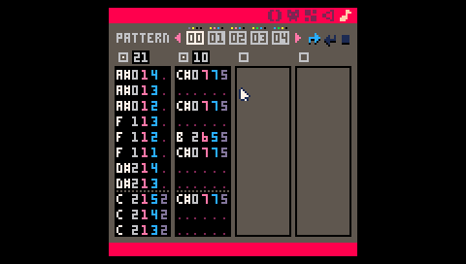

* The **music editor** is where you compose the background music from your created sound effects.
* The music editor allows up to **four effects** at a time for your game’s soundtrack. Click on the boxes above each column to activate the track and choose which effects will be included in each song pattern.
* **Patterns** can be set to move to the next pattern, repeat the current pattern, or stop when finished with the arrow and stop icons on the upper right.
* Pico-8 can hold up to **64 song patterns**.

Learn more from [Pico-8’s manual](https://www.lexaloffle.com/pico-8.php?page=manual).

## Create a Game From Scratch

Creating a game from a blank screen can be quite involved. For brevity, this example illustrates one piece of the overall process. In this short example we will create a new project, draw a sprite, write some code to move our sprite around the screen and save our work. The overarching process can be applied to create a full game that includes a background, music and multiple sprites.

### Create & Save New Project

The first thing to do is to create a new project that can be saved as the game is built. From the ‘**splore menu screen**, press **ESC** and choose “**EXIT TO CONSOLE**”.

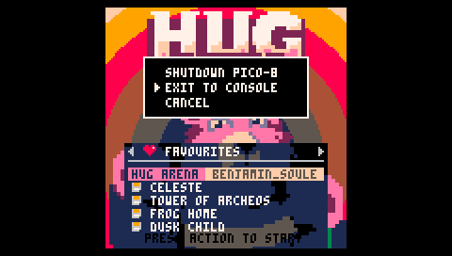

Once in the console reboot Pico-8:

REBOOT

**Tip!** The reboot (restart) will clear Pico-8’s memory which essentially ejects a game that you were playing beforehand. If you were playing or editing a game and do not reboot the next SAVE command will rename and save the code file of that game instead of creating a new blank file.

To check what game is loaded and will be effected press **ESC** to toggle in between the **editors** and **console**. If the editors are empty you are good to go. If not, execute the **REBOOT** command in the console.

Choose a project name and save it by typing:

SAVE [PROJECTNAME]

In my case I called it “MYGAME” (Pico-8 automatically capitalizes all commands since Lua syntax calls for it and is case-sensitive).

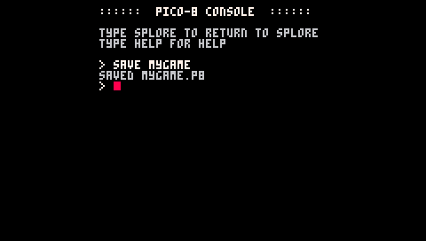

Next, load the newly created project with:

LOAD [PROJECTNAME]

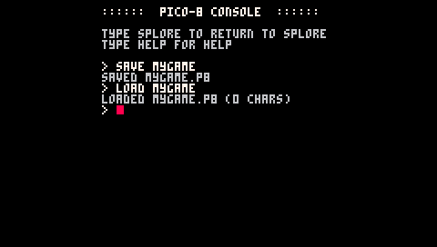

### Create Sprite

Now that a new project has been created and loaded it’s time to start building. To create a sprite press **ESC** which will drop you into the **Code Editor**.

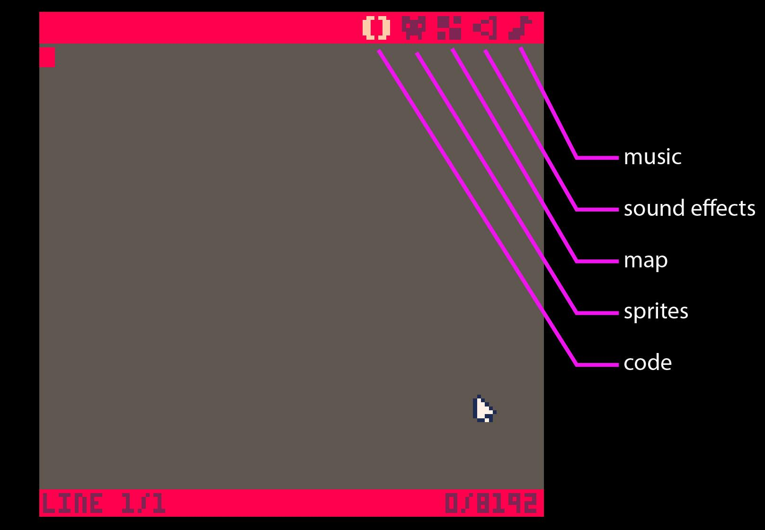

From the Code editor, choose the **Sprite editor** by tapping the appropriate icon in the upper right corner.

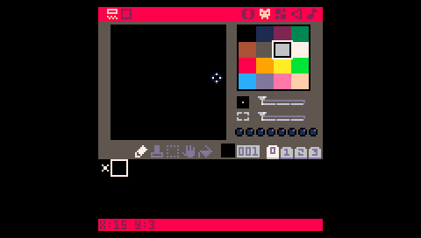

In the Sprite Editor a default “X” design of white pixels can be seen in the upper left corner of the sprite sheet. Each “cell” in the sprite sheet has a corresponding number, this is the sprite’s index number which is used in code to reference that specific design. The “X” is in cell 000 and from left to right it goes up: cell 001, cell 002, etc.

To start creating a custom sprite, **choose an empty cell** or **erase** **the “X”** in cell 000. To erase, select the cell by tapping to display it in the editor window. Erase it by selecting black and then drawing over it with the Draw tool. For this example, I am erasing and drawing my sprite in cell 000.

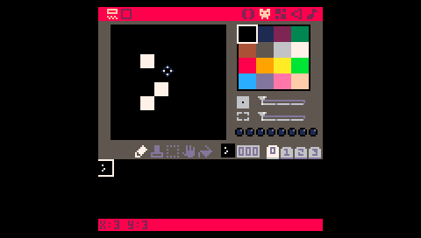

Draw a new sprite.

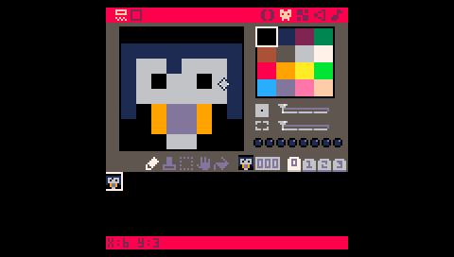

When you are done creating your character save your work by pressing **CTRL+S**. A message of “SAVED [PROJECTNAME.P8]” will appear at the bottom.

### Write Code

Now, let’s write some code that will move our sprite across the screen. Go to the **Code editor** by tapping the () icon. To draw the new sprite on the screen and map the D-pad keys to movement, type:

X = 64

Y = 64

FUNCTION _UPDATE()

IF (BTN(0)) THEN X=X-1 END

IF (BTN(1)) THEN X=X+1 END

IF (BTN(2)) THEN Y=Y-1 END

IF (BTN(3)) THEN Y=Y+1 END

END

FUNTION _DRAW()

RECTFILL(0,0,127,127,5)

SPR(000,X,Y)

END

Lua isn’t white space sensitive, so formatting the code with tabs and spaces is up to you.

What’s going on in the code.

Create variables to hold an X and Y value.

X = 64

Y = 64

Pico-8 has a game loop that is used in the source code of every game. The game loop updates the display 30 times per second making each game play at 30 frames per second. The first part of the game loop is FUNCTION _UPDATE(). In this function lives all the logic for the next frame including user input which is what we are using it for. Read more about the FUNCTION _UPDATE() [here](http://pico-8.wikia.com/wiki/Update).

FUNCTION _UPDATE()

IF (BTN(0)) THEN X=X-1 END

IF (BTN(1)) THEN X=X+1 END

IF (BTN(2)) THEN Y=Y-1 END

IF (BTN(3)) THEN Y=Y+1 END

END

Within the function we are saying that if **Left** is pressed take whatever is drawn at X and move it one space to the Left. This is repeated for **Right**, **Up** and **Down** all moving one in their respective directions instead of Left. Each button is assigned an **button number** which can be found [here](http://pico-8.wikia.com/wiki/Btn) along with documentation for the **btn() function**.

The _DRAW() function is where all the visuals are drawn to the screen each frame. Here we draw a [rectangle](http://pico-8.wikia.com/wiki/Rectfill) that fills the screen (upper left corner at 0,0 and lower right corner at 127,127) and fills it with the color orange (5). The color number references the Pico-8 color palette. The numbers can also be learned from the [manual](https://www.lexaloffle.com/pico-8.php?page=manual) under Graphics.

Next, we draw a sprite in the center of the screen (64,64 because the screen is 128 x 128 pixels) using the 000 cell to reference it.

FUNTION _DRAW()

RECTFILL(0,0,127,127,5)

SPR(000,X,Y)

END

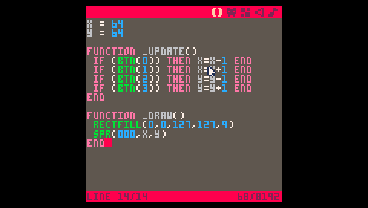

* Save with **CTRL+S** andswitch to the **console** by pressing **ESC**.
* Execute the code written in the Code editor by typing “**RUN**” then pressing **return**.

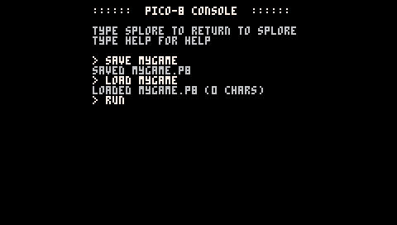

Move the sprite around using the four directions of the D-pad.



Congrats! The next step would be to create a map and maybe some enemies for your new character. Check out the resource section below for more tutorials.

# Exit Pico-8

## From the ‘splore menu

* Press **esc** to get to the console and type “splore” for the ‘splore menu.
* Press **esc** and choose “Shutdown Pico-8”.

## From the Console

* Press **esc** and choose “Shutdown Pico-8”.
* Pico-8 can also be shutdown from the console by typing:

SHUTDOWN

# Pico-8 Resources

[Youtube videos](https://www.youtube.com/results?search_query=PICO-8)

[Pico-8 fanzine](https://sectordub.itch.io/pico-8-fanzine-1)

[Pico-8 manual](https://www.lexaloffle.com/pico-8.php?page=manual)

[Pico-8 website](https://www.lexaloffle.com/pico-8.php)

[Pico-8 Wiki](http://pico-8.wikia.com/wiki/PocketChip)

[NTC Pico-8 Blog Post](http://blog.nextthing.co/resources-to-help-you-learn-pico-8-game-development/)